Monitoring Habitat Loss for Endangered Species Using Satellite Data:   
A Case Study of the Lesser-Prairie Chicken

The Endangered Species Act (ESA) is the primary tool for conserving most imperiled species in the United States. Among its strengths is its ability to protect a variety of habitat for ESA-listed species. But how well do those protections apply on the ground? The U.S. Fish and Wildlife Service has designated over [x] million acres of critical habitat, but no information is available on what percentage of that habitat remains intact. Likewise, the agency has finalized over a thousand ESA conservation agreements, many of which authorize habitat destruction in exchange for mitigation to offset some of those impacts. Perennial funding shortages, however, have left the Service unable to fully monitor for compliance with most of those agreements.[1]

The lack of a comprehensive monitoring program is a serious problem. One example comes from our 2013 analysis of the Texas Conservation Plan for the Dunes Sagebrush Lizard.[2] Using satellite images, we revealed multiple instances of unreported and unauthorized oil well pads and roads in habitat that was supposedly protected under the plan. None of the disturbances appeared in the monthly monitoring reports the permittee provided to the Service, demonstrating the importance of the aphorism, “trust but verify.” Two years later, while browsing on Google Earth and reviewing a random set of ESA habitat conservation plans, we encountered another example of apparent noncompliance. Satellite images revealed that under a Georgia HCP for the eastern indigo snake, over half of a 25-acre parcel of forest had been cleared despite the requirement that the permittee manage the parcel for the species until at least 2027.[3] Situations like these can be a double-blow for species: not only has authorized habitat loss occurred, but the conservation measures to minimize or offset those losses were never fully realized. Left unresolved, this problem could become the weakest link to conserving a species—undermining the expensive and difficult work of listing the species, designating critical habitat, and negotiating conservation agreement.

The problem of inadequate monitoring goes beyond compliance. It also leaves the Service and its partners in the dark about the conservation status of a species. If 60 percent of the habitat across a species’ current range has been degraded, that knowledge should inform how the Service conserves the species. Future permits for habitat loss might undergo closer scrutiny or recovery funding might increase. Unfortunately, the Service has no nationwide program to acquire this type of knowledge.

Although the challenge of inadequate monitoring is not new, most solutions to date have relied heavily on the generosity of Congressional appropriators, a strategy that seems untenable given the current proposals to downsize the federal government. Fortunately, technology empowers the public to help solve the challenge. Perhaps the most promising solutions comes from the growing availability of free satellite images and other remote sensing data. These data, when combined with information on species range and permitted areas, open a wealth of opportunities for habitat and compliance monitoring. As explained earlier, we have already used satellite images for compliance monitoring for the dunes sagebrush lizard and indigo snake. Those projects, however, required us to visually identify habitat disturbances. For example, we had to pan around a map to find new oil drilling pads and roads. While that approach works for smaller landscapes, it is infeasible for species spanning multiple states or for a nationwide monitoring program.

A large-scale monitoring program would require methods to *automatically* detect infrastructure and other habitat changes. Computer algorithms, for example, would detect new oil pads and roads and then present the results to a person for verification. Because we are unaware of any such work for ESA agreements and critical habitat, we decided to develop a habitat change-detection algorithm and evaluate its utility through the lesser prairie-chicken (*Tympanus pallidicinctus*). We selected this species because it is wide-ranging (five states), occupies habitat that is not regularly covered in clouds (thus allowing for clear satellite images), and has experienced extensive habitat loss from infrastructure projects that are relatively easy to detect using satellites and that often involve ESA permits. By showing how automated change detection could apply in an easy scenario, we create the building blocks for tackling more difficult species and habitats in the future. Further, the delisting of the species in September 2015 raised serious concerns about how much habitat the species might lose without ESA conservation requirements. Satellite images offer a convenient way to address that question.

## Lesser Prairie-Chicken

The lesser prairie-chicken (LPC) is native to regions of Colorado, Kansas, Oklahoma, Texas, and New Mexico. Throughout its range, the species requires a mix of sagebrush, native grass prairie, and shrublands. Much of this habitat has been lost to agricultural conversion, and the distribution of LPC is now only 10% of its historical range. Energy development also degrades LPC habitat because the species avoids tall structures – a behavior adapted to avoid aerial predators[4].

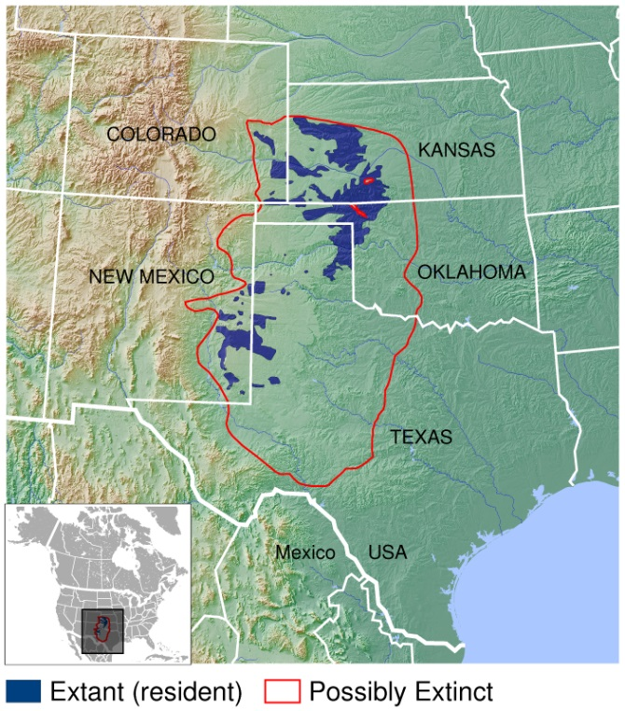The Western Association of Fish and Wildlife Agencies developed a range wide conservation plan (RWP) for the species in 2013, before the U.S. Fish and Wildlife Service listed it in April 2014. Many landowners were able to meet their ESA protection requirements for the LPC by enrolling in the RWP and adopting conservation measures to minimize and offset the effects of their land use activities on the species. A court ruling on September 1, 2015 overturned the listing decision, and the LPC was removed from the endangered species list in April 2016. After the September date, landowners could still voluntarily enroll in the RWP but doing so no longer fulfilled an ESA legal obligation. Without any mandatory ESA protections after the delisting, many conservationists became concerned about the extent to which the species would continue to lose habitat to energy development and agricultural conversion. We quantify the extent of the loss using a combination of publicly available data and remote sensing.

**Lesser prairie-chicken range**

Credit: IUCN Red List spatial data and GLOBE https://commons.wikimedia.org/w/index.php?curid=41506424

## Remote Sensing

In this analysis, the term ‘remote sensing’ describes the use of light reflectance from the Earth’s surface measured by sensors on satellites, to quantify patterns of land cover and land use. A recent proliferation of available satellite data has increased the use of remote sensing in conservation. Many satellite systems collect new images across the globe bi-weekly, advancing the ability to quickly detect and quantify habitat loss. Satellite sensors also measure reflectance values beyond the visible light spectrum, including infrared and ultraviolet light. Compared to photographs, these data allow users to better distinguish among land cover types and features on the Earth’s surface.

In this analysis, we used Google Earth Engine – a platform providing access to terabytes of real-time satellite data, and the cloud computing capabilities to analyze them – to create an automated process to detect wind turbines, oil and gas wells, and habitat loss throughout the LPC’s range. The process involves the following key steps:

1. Acquire satellite data from before and after the date of interest
2. Calculate changes in the Earth’s surface reflectance values using the data
3. Set thresholds for the changes in reflect values that correspond to the habitat loss we are seeking to identify
4. Select pixels exceeding these change thresholds
5. Distinguish man-made from natural changes

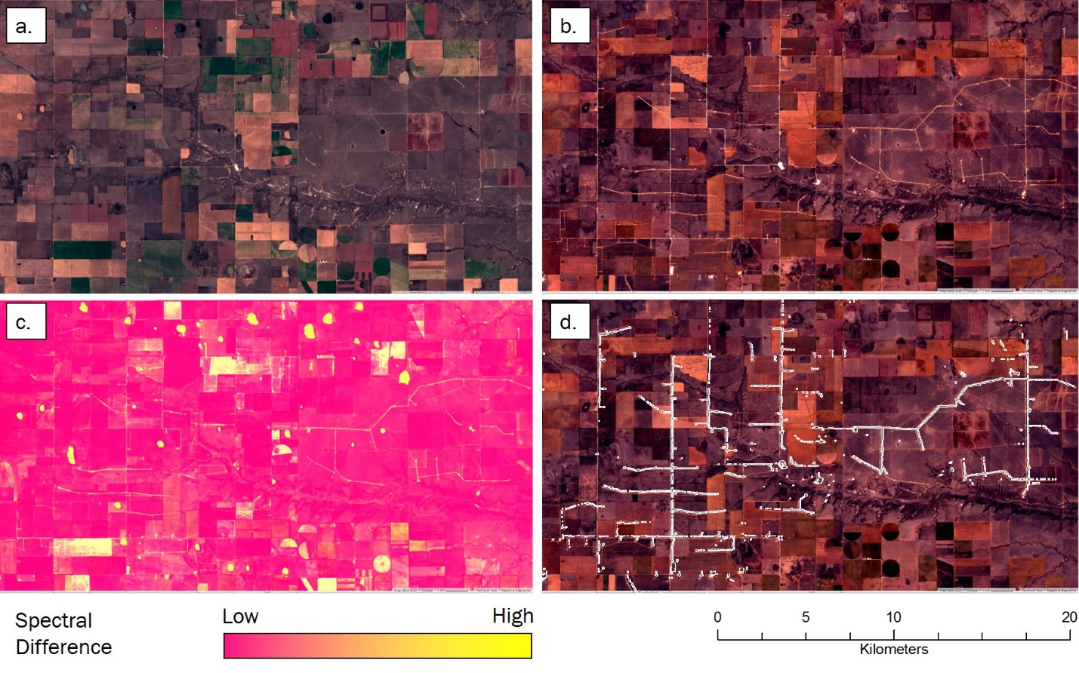

**Figure 1** Images at a wind farm constructed after September 1, 2015 outlining the process of automated land cover change detection. First, images from before (a) and after (b) the date of interest are collected and processed, displayed here in the visible red-green-blue spectrum. A suite of metrics measuring changes in multiple, different reflectance values are calculated and combined into an image representing the likelihood of land cover change (c). Pixels with change values exceeding pre-determined thresholds are selected, indicating areas of human disturbance (e.g., roads and turbine pads) occurring between before and after images (d). This process is applied across an area of interest to automatically detect human disturbances.

# Findings

## Wind Energy Development

Using our automated change detection process, we identified five wind farms with a total of 713 turbines constructed after September 1, 2015 within LPC range. The RWP uses a buffer of 667 meters around turbines to determine the area for which mitigation is needed. Under the RWP, construction of these 713 turbines would create 129,739 acres of potential mitigation area. From a biological perspective, however, LPC avoid tall structures up to 1 mile away. FWS considers areas within 1 mile of wind turbines as biologically disturbed or degraded habitat[5]. When a 1 mile buffer is considered, these 713 turbines create 257,577 acres of habitat disturbance for LPC.

## Oil and Gas

We used two methods to identify oil and gas wells constructed after September 1, 2015. The first method is based on reviewing oil and gas drilling permits and production records maintained by state oil and gas commissions, including project start dates and well locations. In theory, these records can identify the number and location of disturbances within LPC habitat from oil and gas activities. We obtained all records (378) of new wells reported between September 1, 2015 and [insert end date] within LPC range.

We then used satellite images to verify whether each well actually existed. We first had to determine if satellite images were available to verify the presence of each well. For 310 of the wells, we found useable images of their reported location. For the remaining 68 wells, all images were unusable because they captured too many clouds. Of those 310 wells, we found that only 178 (57%) actually existed—meaning the images showed a well within 500 m of the location reported in the state records (Table 1). If a well appeared more than 500 m from its reported location, our confidence was low that it represented the reported well.

**Table 1.** Counts of new oil and gas wells within LPC range that were reported by state oil and gas commissions constructed between September 1, 2015 and [insert end date]. ‘Inspected’ wells were those for which we found usable satellite images. Of those wells, only the “detected” ones actually existed according to satellite images.

|  |  |  |  |  |
| --- | --- | --- | --- | --- |
| **STATE** | **Wells Reported** | **Wells Inspected** | **New Wells Detected** | **Detection Rate** |
| CO | 1 | 1 | 1 | 100% |
| NM | 63 | 25 | 23 | 92.0% |
| TX | 132 | 105 | 49 | 46.7% |
| KS | 163 | 163 | 46 | 28.2% |
| OK | 19 | 16 | 3 | 18.7% |
| **TOTAL** | **378** | **310** | **178** | **57.4%** |

The discrepancies between wells reported and detected could have been caused by errors when a state recorded the dates or coordinates of a well, by unreported changes in project timelines, or in many cases by vague construction dates in the state records. For instance, New Mexico reports a ‘spud date,’ the date on which ground was broken when drilling a new well. By contrast, Kansas provides only a ‘year start’ with well records, which leaves the actual construction date ambiguous. We confirmed the construction of new wells at 92% of reported locations that we checked in New Mexico, but only 28% of those in Kansas.

We then used a second method to identify any additional wells not detected by the first method. This second method uses a change detection algorithm we developed to identify new oil and gas wells. We applied the algorithm to satellite data across LPC range and identified 179 new well pads that appeared since delisting. The 179 wells are in addition to the 178 wells identified using our first method, leaving us with a total of 357 new wells since September 1st.

The RWP uses a buffer of 200 m around oil and gas wells to determine the area for which mitigation is needed. The 357 wells represent 8,950 acres of mitigation that would be required if all the wells were enrolled under the RWP.

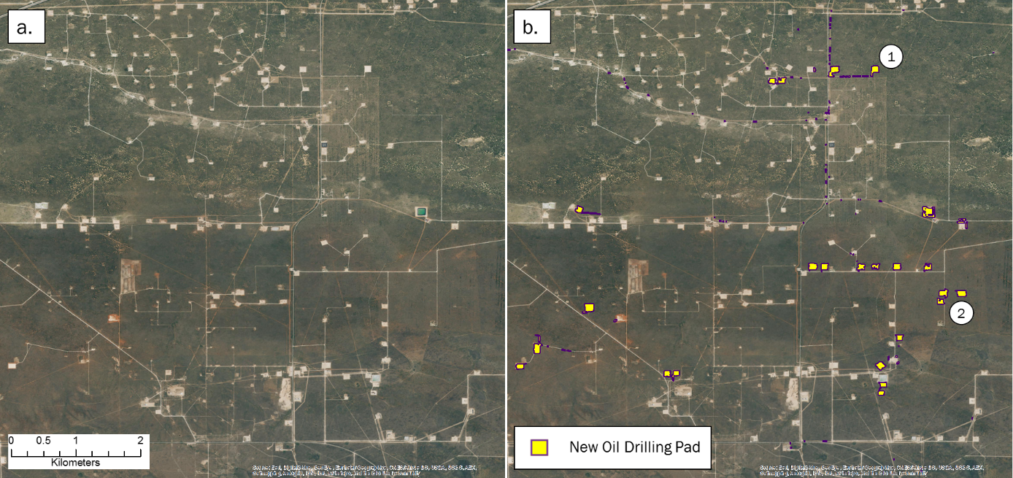

**Figure 2.** Example of oil well pads constructed between September 1, 2015 and April 1, 2017 identified by our change detection algorithm applied to satellite images. Images in (a) and (b) are the most recent aerial photographs available on Google Earth (from October 4, 2016). Some pads constructed within the study period are already visible (1), while others constructed more recently are only detectable by more frequently collected remote sensing data (2).

In total, we detected 1,070 disturbances from energy development within LPC range between the September 2015 delisting and April 1, 2017, creating 138,689 acres of potential mitigation area under the RWP (Figure 3). It is important to note that the thresholds we used to detect well pads and wind turbines were selected to minimize the chance of false positives (*e*.*g*., identifying a well pad where none exists). Because of this conservative approach, our algorithms likely did not capture all actual habitat disturbances since delisting, so the 1,070 disturbances represent a minimum amount.

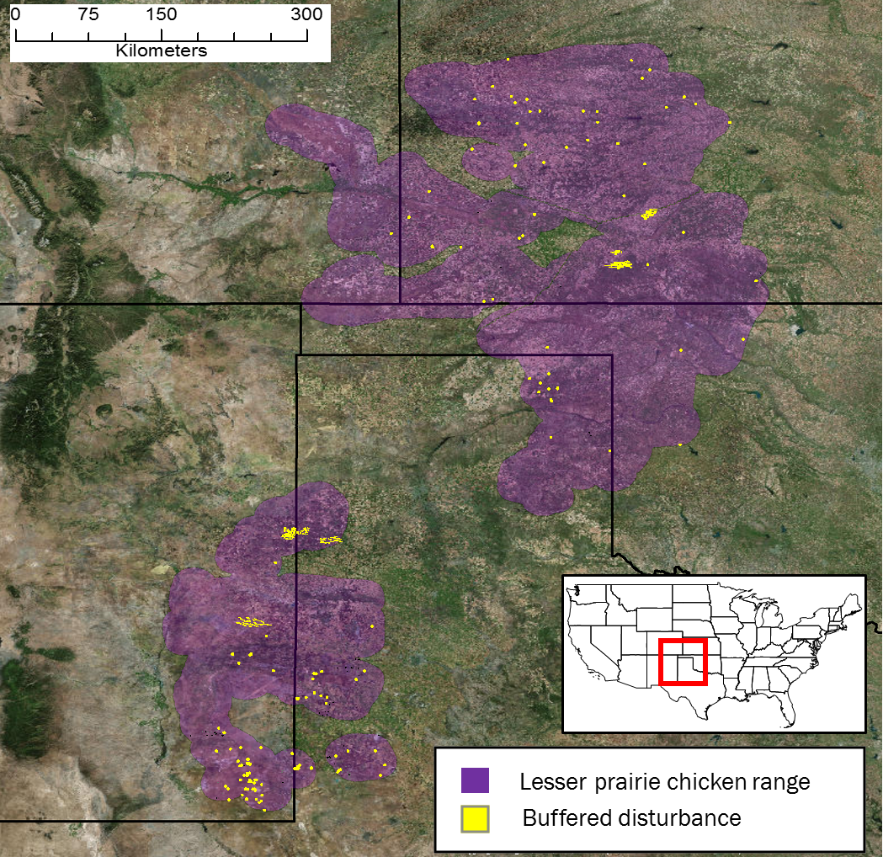

**Figure 3** Locations of wind farms and oil and gas wells within lesser prairie-chicken range constructed between September 1, 2015 and April 1, 2017 identified by automated land cover change detection. The range map comes from the range-wide plan, which uses the map to evaluate mitigation requirements. The range includes a 10 mile buffer around existing LPC habitat.

## Habitat Loss from Agriculture

In addition to tracking disturbance from energy development, we estimated the loss of LPC habitat from conversion of native grass prairie and shrubland to agriculture since delisting. The majority of habitat loss since delisting is from agricultural conversion. Using annual cropland data from the U.S. Department of Agriculture (USDA), we estimated that between 85,000 and 184,000 acres of LPC habitat was converted from LCP habitat in 2015 to agriculture in 2016 (Figure 4). The range of estimated acreage is based on different level of confidence in the classification USDA assigns to each pixel of its cropland data. The lower value of 85,000 acres was calculated only from areas with over 90% confidence that LPC habitat in 2015 was converted to agriculture in 2016. Lowering this confidence threshold to 75% produces an estimated 184,000 acres converted.

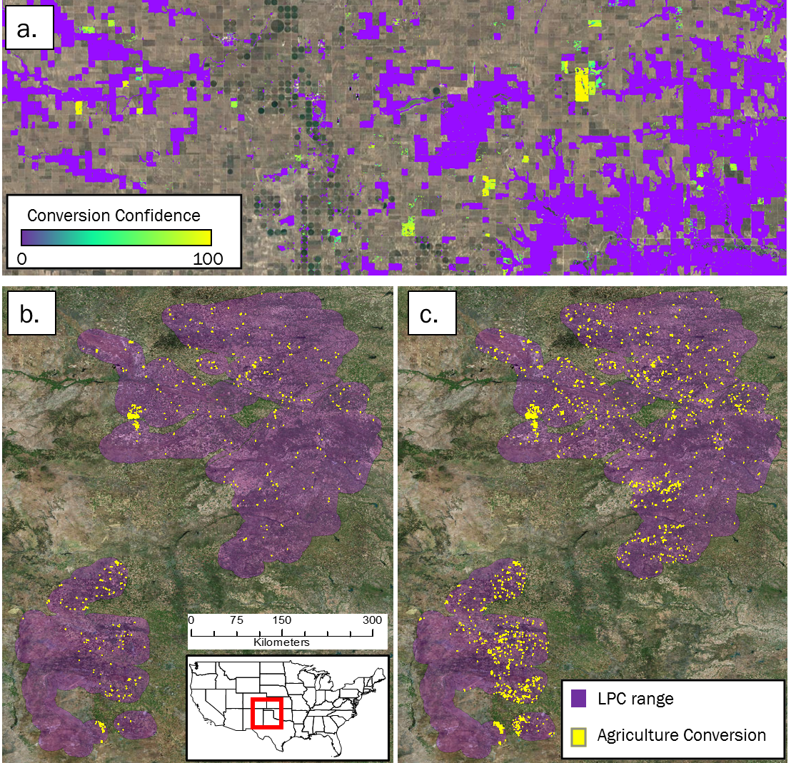

**Figure 4** Conversion of lesser prairie-chicken habitat in 2015 to agriculture in 2016. A raw score of conversion probability (a) was used to identify areas of agricultural conversion across lesser prairie-chicken range, selecting areas with at least 90% confidence (b), and 75% confidence (c).

# Methods

## Satellite Data for Agricultural Conversion

For automated change detection using the algorithm we developed, we used pre-processed Sentinel-2 satellite imagery, available on Google Earth Engine, to conduct change detection analyses. Sentinel-2 is a remote sensing satellite system deployed and maintained by the European Union, providing global coverage of 10 m resolution imagery every 12 days. Sentinel-2 images contain 12 bands that record reflectance values in the visible, near infrared, short-wave infrared, and near ultraviolet spectra. To avoid the potential for seasonal phenology to confound true land cover change, we first selected Sentinel-2 scenes across LPC range acquired outside of the growing season (November to March). Scenes collected in 2015/16 were used as ‘before’ imagery and those in 2016/17 as ‘after’. We removed cloudy pixels from each image using a filter on the provided quality assurance band, which identifies clouds, shadow, snow, and water, and created a single image composite by selecting the median value of each pixel stack.

To detect conversion of LPC habitat to agriculture, we used Landsat-8 orthorectified top-of-atmosphere reflectance imagery, available on Google Earth Engine. Landsat-8 is a remote sensing satellite system deployed and maintained by the U.S. Geological Survey, providing global coverage of 30 m resolution imagery every 16 days. To calculate changes in greenness over the course of the growing season, we selected Landsat-8 scenes across LPC range acquired between April and October. We defined scenes collected in the growing season of 2015 as ‘before’ conditions, and those collected in 2016 as ‘after’ conditions. We removed cloudy pixels from each image using the Fmask[6] algorithm, which calculates the probability that a pixel is a cloud, shadow, or snow. We excluded pixels with a probability exceeding 0.2.

## Change Detection Algorithm for Agricultural Conversion

Our automated change detection algorithm extended the method used by the U.S Geological Survey to produce the National Land Cover Dataset (NLCD) land cover change data[7]. We calculated four spectral change metrics between before and after imagery. The Change Vector (CV) measures the total change in reflectance values between two images across the visible and infrared spectrum, and Relative CV Maximum (RCVMAX) measures the total change in each band scaled to their global maxima. Differences in Normalized Difference Vegetation Index (dNDVI) uses ratios between near infrared and red reflectance to indicate changes in the concentration of vegetation. We also calculated differences in a Ratio Normalized Difference Soil Index (dRNDSI)[8], which uses ratios between short-wave infrared and green reflectance to indicate changes in the concentration of bare ground. We then converted pixel values for each change metric to z-scores representing the likelihood of land cover change relative to global means for normalized indices (RNDSI & NDVI), and global minimums for scaled indices (CV and RCVMAX). The output was a four-band image consisting of the standardized z-scores for each change metric at each pixel, covering the entire LPC range. All calculations and transformations were performed in Google Earth Engine.

## Change Validation for Energy Development

Because of the distinct spatial pattern of wind farms (Figure 1d), we identified new farms by examining the change metric output visualized to highlight losses in vegetation and increases in bare ground. We then visually inspected the most recent available Sentinel-2 imagery at new wind farm locations to identify and mark individual turbines.

Oil and gas well pads are small and less distinct, allowing us to readily define the reflectance thresholds that represent replacement of natural land cover with well pads. We selected 100 validation plots from the change metric image in areas with high change likelihoods that did (true positive) and did not (false positive) correspond to the addition of well pads. We extracted the change metric z-scores within these validation plots, and performed linear discriminant analysis (LDA) to estimate the coefficients for a linear transformation maximizing differentiation between true and false positive validation data. We used a receiver operating characteristic (ROC) curve and selected the LDA score maximizing the second derivative (i.e., rate of change in curve slope) of the relationship between false positive and detection rate (Figure 4a), as a threshold for automatically identifying new well pads. We then converted areas meeting or exceeding this threshold to change polygons. LDA and ROC analyses were conducted in *R* using the *pscl* and *pROC* packages.

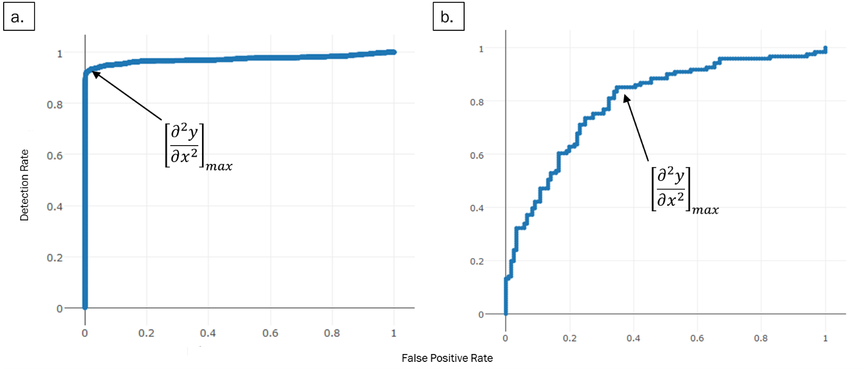

**Figure 4** Receiver operating characteristic (ROC) curves plotting linear discriminant analysis scores for change metrics (a) and shape metrics (b) to identify new oil and gas well pads. The values at which the rate of increase in detection rate relative to false positive rate decreases most rapidly (indicated by arrows) were selected as threshold values.

We then needed to discriminate between natural land cover changes that matched well pad spectral characteristics, and true human disturbances. We calculated a suite of shape metrics for each land cover change polygon, including convexivity, circularity, elongation, and compactness, that had the potential to distinguish more regular, compact shapes formed by human activity from irregular shapes associated with natural land cover change[9]. We then manually classified a validation set of 400 polygons and, as with reflectance thresholds, used LDA and ROC curves to identify values discriminating between true and false positives (Figure 4b). We then examined the most recent Sentinel-2 imagery at each polygon that met spectral and shape criteria to confirm the presence of a well pad constructed after September 1, 2015, and deleting all other polygons. For each choice of threshold, the true positive detection rate was less than one, and therefore this approach eliminated a small set of true human disturbances. Thus, our results represent a minimum number of new pads.

## Mitigation Area Calculation

We further restricted the set of oil and well pads to those occurring within areas identified as shrub/scrub or grassland by the NLCD 2011 classifications. This eliminated disturbances occurring within already degraded habitat (e.g., agriculture) from further consideration. The RWP uses a buffer of 200 meters around oil and gas wells and 667 meters around wind turbines to determine the disturbed acres that must be offset by habitat mitigation. To estimate lost potential mitigation opportunities, we buffered the new well pad polygons and turbine locations by 200 and 667 meters, respectively. We then eliminated buffered areas where disturbances were already present (Figure 5a), as the disturbances could have already been mitigated[10]. The potential mitigation acreage was the total acreage of all remaining buffered areas.

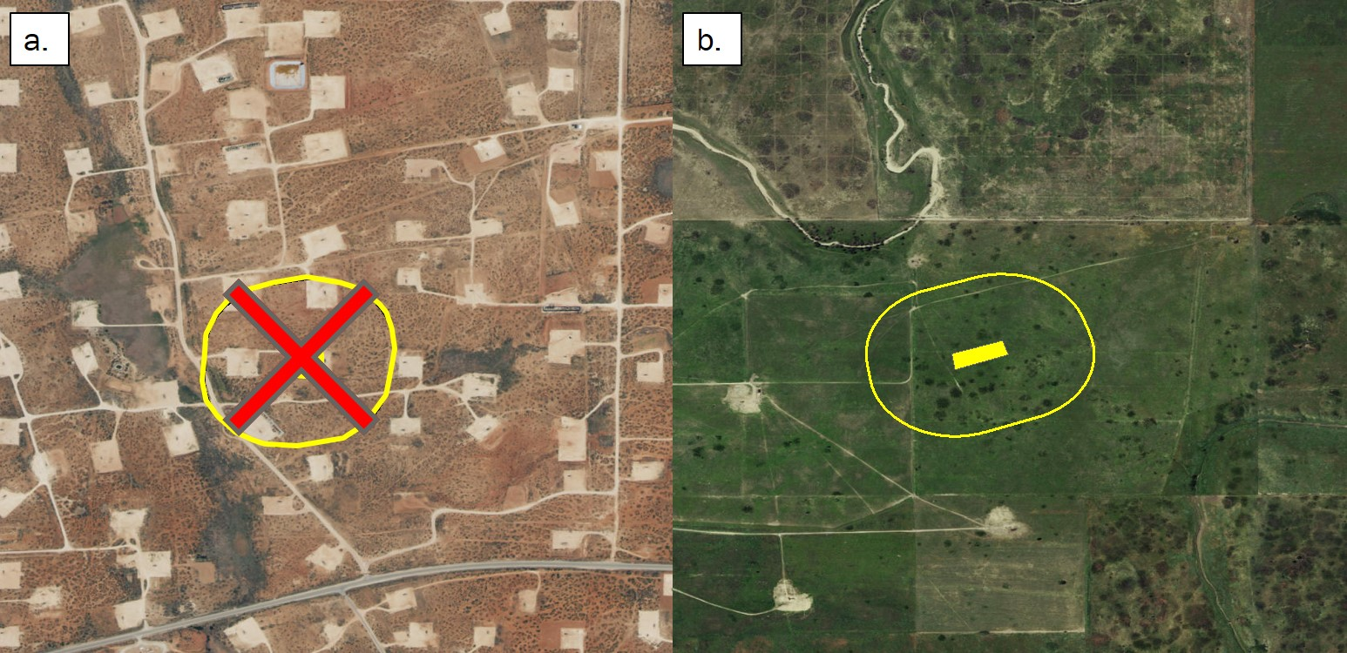

**Figure 5** Buffered areas surrounding oil and gas wells encompassing already highly disturbed areas (a) were not included in our calculation of total potential mitigation acreage. Only areas containing primarily intact LPC habitat (b) were included.

## Agricultural Conversion

We used two approaches to estimate the area of LPC habitat converted to agricultural land since the species was delisted. For both approaches, we considered the growing season (May 01 – September 01) of 2015 to represent ‘before’ conditions, and the growing season of 2016 as ‘after’ conditions.

Our first approach followed similar methodology to a previous study of habitat loss[11], and used the U.S Department of Agriculture’s annual Cropland Data Layer (CDL). This product classifies agricultural land by crop type across the United States, using a combination of satellite reflectance, elevation, and ground-truthing data[12]. The product is a 30 m resolution raster whose pixels have a ‘cropland’ value designating crop type, and an assignment confidence score [0, 1]. To estimate LPC habitat conversion to agriculture, we selected pixels classified as either scrubland or grassland in the 2015 CDL, and as any crop type in the 2016 CDL. We performed this calculation using two different confidence thresholds, excluding pixels with < 75% assignment confidence, and excluding pixels with < 90% confidence. We applied two successive majority filters to each result to eliminate single, isolated pixels in order to create more contiguous areas of change or non-change. Areas representing change were then converted to polygons. Finally, because of the concave and patchy nature of the per-pixel output, we created minimum-area bounding boxes around each polygon, which more accurately represent the footprint of an agricultural parcel. The sum area of all resulting polygons was used as the first estimate of habitat loss.

Our second approach used measures of intra-annual variation in greenness, as indicated by NDVI. We calculated NDVI across LPC range using Landsat-8 30 m resolution images obtained between April 30 and September 1 in 2015 (before) and 2016 (after). For each year, we calculated the dispersion (sample variance normalized by sample mean) and maximum NDVI value across images at each pixel. Our expectation was that agricultural land cover would have both greater variance and maximum NDVI values throughout a growing season than would natural landcover. Thus, conversion from LPC habitat to agriculture would be indicated by an increase in both values from 2015 to 2016. To estimate the likelihood of conversion, we calculated the difference between NDVI dispersion and maxima between the two years.

Small sample size can bias estimates of dispersion. Therefore, we adjusted observed NDVI metrics by a measure of uncertainty based on the number of images available at a pixel location. The probability of true population variance (*σ2*) given a sample variance (*s2*)and sample size (*n*) can be estimated by an Inverse Gamma distribution: *P(****σ2***| *s2, n) ~ IG(n/2, (n-1)*s2/2)*. We used the ratio of the probability density for the observed sample variance from a distribution parameterized by the actual sample size, to one parameterized by the maximum possible sample size, as an adjustment factor for observed dispersion. The adjustment factor (*AF*) for observed dispersion at a given pixel *i* was:

$${AF}_{i}= \frac{ P\left(σ_{i}^{2} \right|s_{i}^{2}, n_{i})}{P(σ_{i}^{2} | s_{i}^{2} , n_{max}) }=\frac{\frac{{s_{i}^{2}{n_{i}}/2}^{n_{i}/2}}{Γ\left({n_{i}}/2\right)}*{σ_{i}^{2}}^{-\frac{n_{i}}{2}-1}e^{-\frac{s_{i}^{2}n_{i}/2}{σ_{i}^{2}}}}{\frac{{s_{i}^{2}{n_{max}}/2}^{n_{max}/2}}{Γ\left(n_{max}/2\right)}*{σ_{i}^{2}}^{-\frac{n_{max}}{2}-1}e^{-\frac{s_{i}^{2}{n_{max}}/2}{σ_{i}^{2}}}}$$

We adjusted all NDVI dispersion values by the adjustment factors per pixel, using the maximum number of images available within the growing season (16) as $n_{max}$.

To identify thresholds representing true conversion of LPC habitat to agriculture, we generated distributions for expected differences in NDVI dispersion and maximum values between habitat and agricultural land cover types. We took a random sample of NDVI dispersion, maximum, and image count values at 50,000 pixels where image count was at least 6. We used the CDL to further restrict this sampling to pixels with an assignment confidence of at least 90%, and extracted the ‘cropland’ attribute. This created a dataset of NDVI dispersion and maximum values for each crop and landcover type. From this data, we generated probability distributions for the expected change in NDVI dispersion and maxima corresponding to conversion between all combinations of shrub/grassland, alfalfa, corn, wheat, sorghum, and fallow land cover types by iteratively calculating the difference between 5,000 random samples drawn from the observed distributions for each crop and habitat category (Figure 7). We calculated the densities across values, and standardized to sum to 1. From these distributions, we calculated the cumulative probability that an observed change in NDVI dispersion and maximum values corresponded to land cover change from LPC habitat to agriculture.

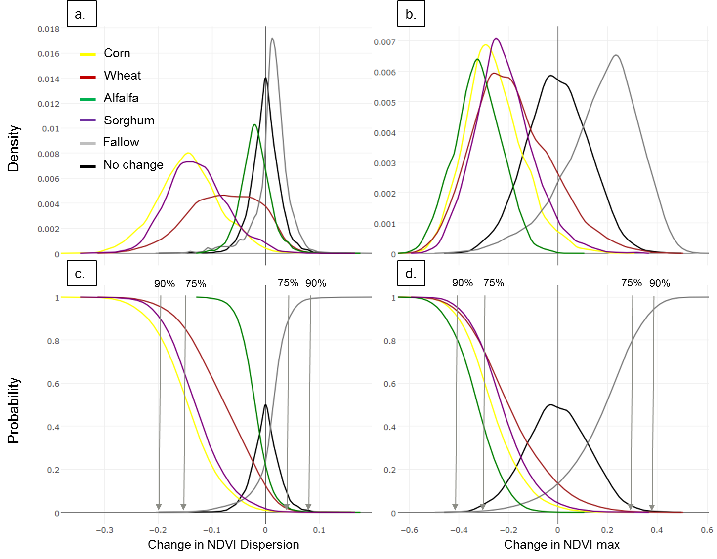

**Figure 6** Probability distributions for expected changes in NDVI dispersion and maxima if land is converted from lesser-prairie chicken habitat to different crop types. Curves represent the frequency of expected values (a, b), and probability of observing a change value (c, d) for each form of conversion. Curves were used to select threshold change values, indicated by grey arrows, identifying when conversion occurred between growing seasons of 2015 and 2016, with 75%, and 90% confidence.

We estimated the probability of conversion as the sum of the probabilities of the observed change value given conversion to each agricultural class – defined by the inverse of the cumulative distributions of expected differences for each crop type – multiplied by the probability of the observed change value given no change – defined as the cumulative distribution of expected differences for unchanged habitat. To detect conversion to fallow land, we used the cumulative distribution of expected differences for change from habitat to fallow, and the inverse cumulative distribution for unchanged habitat.

# Conclusion

[To be written later. Should cover (1) whether our automated change detection method was effective and useful, (2) the extent of LPC habitat loss since delisting. Wrap up with prospects for large-scale habitat monitoring using automated change detection.]

1. Management Systems International, An Independent Evaluation of the U.S. Fish & Wildlife Service’s Habitat Conservation Plan Program (Sept. 2009) (finding that HCP “performance data are not tracked and individual HCP data records often contain incomplete sets of data; data that are supposed to be collected often are not and thus many HCP records are incomplete.” Except for the Olympia Field Office, the majority of FWS field office visited had “no standard operating procedures for validating compliance reports or conducting site visits.” “Nearly 75% of FWS staff surveyed said that they had neither sufficient time nor resources to monitor compliance and implementation of the HCPs they supervised.”).
2. Texas has mismanaged habitat plan for imperiled lizard – report, EENews (Aug. 19, 2013), available at: https://www.eenews.net/stories/1059986184
3.
4. Hagen, C.A. et al. (2011) Impacts of anthropogenic features on habitat use by Lesser prairie-chickens. In: *Ecology, conservation, and management of grouse. Studies in Avian Biology*, University of California Press, Berkeley, CA.
5. Determination of Threatened status for the Lesser prairie-chicken. U.S. Fish and Wildlife Service, April 10, 2014.
6. Zhu, Z. et al. (2015) Improvement and expansion of the Fmask algorithm: cloud, cloud shadow, and snow detection for Landsats 4-7, 8, and Sentinel 2 images. *Remote Sensing of Environment, 159*: 269-277.
7. Jin, S. et al. (2013) A comprehensive change detection method for updating the National Land Cover Database to circa 2011. *Remote Sensing of Environment*, 132: 159-175.
8. Deng, Y. et al. (2015) RNDSI: A ratio normalized difference soil index for remote sensing of urban/suburban environments. *International Journal of Applied Earth Observation and Geoinformation*, 39: 40-48.
9. Jiao, L. & Liu, Y. (2012) Analyzing the shape characteristics of land use classes in remote sensing imagery. *ISPRS Annals of the Photogrammetry, Remote Sensing and Spatial Information Sciences, (I-7)*:135-140
10. Van Pelt, W.E. et al. (2013) The Lesser prairie-chicken range-wide conservation plan. *Western Association of Fish and Wildlife Agencies*, Cheyenne, WY.
11. Faber, S. et al. (2012) Plowed Under. *Environmental Working Group*: http://static.ewg.org/pdf/plowed_under.pdf
12. Boryan, C. et al. (2011) Monitoring US agriculture: the US Department of Agriculture, National Agricultural Statistics Service, Cropland Data Layer Program. *Geocarto International, 26(5)*: 341-358.